# Quinte Financial Technologies | FinTech Solutions

**Assignment on**

**VOLCKER’S RULE AND RETAIL BANKING OPERATIONS**

**Under Supervision of:**

**Mr. Mohammad Mozammil**

**Submitted On:**

**17th June, 2024**

**Submitted By:**

**Archita Gupta**

Table of Contents

Volcker’s Rule 3

Retail Banking Operations 5

# Volcker’s Rule

The Volcker Rule is a federal regulation that generally prohibits banks from conducting certain investment activities that contributed to the 2007–2008 financial crises. Essentially, it prohibits banks from using their own accounts for short-term proprietary trading of securities, derivatives, and commodity futures, as well as options on any of these instruments and limits their dealings with hedge funds and private equity funds, also called covered funds.

* On June 25, 2020, Federal Deposit Insurance Corp. (FDIC) officials said the agency will loosen the restrictions of the Volcker Rule, allowing banks to more easily make large investments into venture capital and similar funds.
* The main criticism of the Volcker Rule is that it will reduce liquidity due to a reduction in banks’ market-making activities.
* Banks that have total consolidated assets equal to $10 billion or less and total trading assets and liabilities equal to 5 percent or less of total consolidated assets are generally exempt from the Volcker rule.

**Key Provisions of the Volcker Rule**

1. **Proprietary Trading Restrictions**
   * **Definition**: Proprietary trading refers to the practice of banks trading stocks, bonds, derivatives, and other financial instruments for their own profit, rather than on behalf of customers.
   * **Restriction**: Banks are prohibited from engaging in proprietary trading activities, except for certain permitted activities, such as market making, hedging, underwriting, and trading in government securities.
   * According to a 2019 study by the Office of Financial Research (OFR), the Volcker Rule has led to a significant reduction in proprietary trading activities among large banks. The study found that proprietary trading by U.S. banks decreased by approximately 25% after the implementation of the rule.
2. **Covered Funds**
   * **Definition**: Covered funds include hedge funds, private equity funds, and other similar investment vehicles.
   * **Restriction**: Banks are prohibited from owning, sponsoring, or having certain relationships with covered funds to limit exposure to high-risk investments.
   * A Federal Reserve analysis in 2017 indicated that the total exposure of large bank holding companies to covered funds decreased by over 50% from 2014 to 2016, reflecting a substantial reduction in riskier investments.
3. **Compliance Programs**
   * **Requirement**: Banks must implement robust compliance programs to ensure adherence to the Volcker Rule. This includes establishing internal controls, training, and independent testing.
   * The U.S. Office of the Comptroller of the Currency, which regulates nationally chartered banks, estimated the Volcker rule's cost at between $413 million and $4.3 billion. These would be one-time costs taken in one year.
4. **Metrics Reporting**
   * **Requirement**: Banks are required to report quantitative metrics to regulators to monitor compliance with the rule. These metrics include risk and position limits, inventory turnover, and revenue from trading activities.

# Retail Banking Operations

Retail banking, also known as consumer banking or personal banking, is banking that provides financial services to individual consumers rather than businesses. Retail banking is a way for individual consumers to manage their money, have access to credit, and deposit their funds in a secure manner.

* Services offered include savings and checking accounts, mortgages, personal loans, debit or credit cards, certificates of deposit (CDs), and more.
* Today, many fintech companies can provide all the same services as retail banks through internet platforms and smartphone apps.
* While retail banking services are aimed at individuals in the general public, corporate banking services are offered only to small or large companies and corporate bodies.

As of March 31, 2023, the top five largest U.S. commercial banks by assets were:

* JPMorgan Chase
* Bank of America
* Citibank
* Wells Fargo
* U.S. Bank

Credit unions are another type of retail bank that works as a non-profit cooperative where members pool their assets to be able to provide loans and other financial services to other members.

**Key Components of Retail Banking Operations**

1. **Deposit Accounts**
   * **Savings Accounts**: Interest-bearing accounts that allow customers to save money.
   * **Checking Accounts**: Accounts used for daily transactions, typically offering features like check writing and debit card access.
   * **Certificates of Deposit (CDs)**: Fixed-term deposits offering higher interest rates than regular savings accounts, but with limited liquidity.
2. **Loan Products**
   * **Personal Loans**: Unsecured loans provided for personal use, such as debt consolidation or major purchases.
   * **Mortgages**: Loans secured by real estate property, used to purchase homes.
   * **Auto Loans**: Loans specifically for the purchase of vehicles.
   * **Credit Cards**: Revolving credit lines allowing consumers to borrow up to a certain limit for purchases and cash advances.
3. **Payment Services**
   * **Debit and Credit Cards**: Payment cards linked to checking accounts (debit) or offering a line of credit (credit).
   * **Electronic Funds Transfers (EFTs)**: Online and mobile banking transfers, including bill payments and person-to-person (P2P) transfers.
   * **Automated Teller Machines (ATMs)**: Machines providing cash withdrawals, deposits, and other banking services.
4. **Investment and Wealth Management**
   * **Investment Accounts**: Accounts for buying and holding securities, such as stocks, bonds, and mutual funds.
   * **Retirement Accounts**: Accounts like IRAs and 401(k)s designed for long-term retirement savings.
   * **Financial Planning**: Services offering advice on investments, estate planning, and tax strategies.
5. **Insurance Products**
   * **Life Insurance**: Policies providing a death benefit to beneficiaries.
   * **Health Insurance**: Policies covering medical expenses.
   * **Property and Casualty Insurance**: Policies covering homes, automobiles, and other personal property.

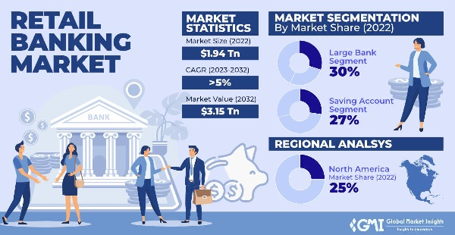

Market Size (2022): $1.94 Trillion

Market Value (2032): $3.15 Trillion

Market Segmentation by Market Share (2022):

* Large Bank Segment: 30%
* Saving Account Segment: 27%

Regional Analysis:

* North America Market Share (2022): 25%

2024 data:

|  |  |  |
| --- | --- | --- |
| **Age group** | **Percent who primarily use online banking** | **Percent who primarily use mobile banking** |
|  |
| 12-27 | 11% | 57% |
| 28-43 | 14% | 60% |
| 44-59 | 17% | 52% |
| 60-78 | 39% | 31% |

**Share of bank account holders processing banking matters via mobile banking (smartphone or tablet) in the United States:**

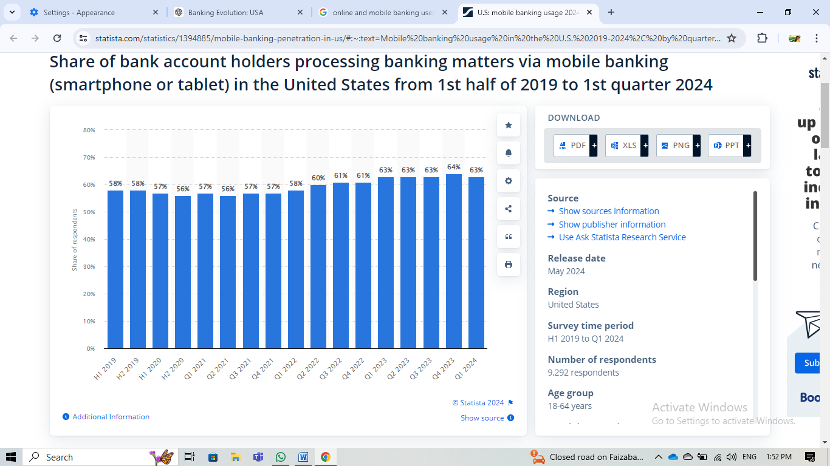

The share of expenditure remains relatively stable, ranging from around 56% to 64%, throughout the time period shown. There is a noticeable increase from around 58% in the earlier years to around 60-61% in the middle years, and then a further increase to around 63-64% in the most recent years.

Thank You